railway reservation system

**SRS Documentation for Railway Reservation System**

**OBJECTIVE**

To develop software for railway reservation system with various functional and non- Functional part of design namely,

1. PROBLEM ANALYSIS AND REQUIREMENT ANALYSIS.
2. TRAIN ENQUIRY
3. TICKET GENERATION
4. TICKET CANCELLATION

The ultimate goal of this project is to develop a database that integrates the process of the Reservation of railway

**INTRODUCTION**

The purpose of this source is to describe the railway reservation system which provides the train timing details, reservation, billing and cancellation on various types of reservation namely,

1. Confirm Reservation for confirm Seat.
2. Reservation against Cancellation.
3. Waiting list Reservation.
4. Online Reservation.
5. PNR Generation

**TECHNOLOGY USED**

**1. USER INTERFACE:**

* Keyboard and Mouse

**2. HARDWARE REQUIREMENT:**

* Printer
* Normal PC
* CPU – Intel Core 2 Duo E7300
* RAM – 512MB (MIN)
* Hard Disk – 80GB

**3. SOFTWARE REQUIREMENT:**

* Turbo C++, C

**4. OPERATING ENVIRONMENT:**

The OS used are

* Windows 97
* Windows XP

**INTENDED AUDIENCE:**

The different types of readers are

1. Developers
2. Customers
3. Management people specifically,
4. Passengers
5. Clerk

**DEFINITIONS, ACRONYMS AND ABBREVIATIONS**

1. NTES – National Train Enquiry System
2. IVRS – Interactive Voice Response system
3. PRS – passenger reservation system

It consists of

* + Train details
  + Reservation form
  + Billing
  + Cancellation.

GENERAL DESCRIPTION It enables us to maintain the railway train details like their timings, number of seat available and reservation billing and cancelling the tickets.

**COMMUNICATION INTERFACES**

* Indian Railway’s web-site, www.indianrail.gov.in offers PRS enquiries on the internet Berth/Seat availability, Passenger Status, Fare, Train Schedule etc,.
* National Train Enquiry System (NTES) website, www.trainenquiry.comgives dynamic information about the running status of any train and its expected arrival/departure at any given station.
* Mobile telephone based SMS enquiry service. A new mobile phone based facility for rail users’ which is. Country wide extension of Universal Rail Enquiry number “139”through setting up of Interactive Voice Response System (IVRS).

**OPERATIONS**

1. Any Reservation counter from 8 am to 8 pm.
2. Prior to 90 days of Journey.
3. One form for 6 persons only.
4. To save time & queues Agent is others guides.

**PRODUCT FUNCTION**

* It tells the short note about the product.

**TRAIN DETAILS**

* Customers may view the train timing at a date their name and number of tickets.
* Passengers operated Enquiry Terminals.

**PERFORMANCE REQUIREMENTS**

* + It is available during all 24 hours.
  + Offered through Mail express, super-fast, Rajdhani & Shatabdi Trains.
  + About 1520 Trains runs daily.

**Variety of compartments based on comfort:**

* + AC first class.
  + AC sleeper.
  + First class.
  + AC three tier.
  + AC chair car.
  + Sleeper class
  + Ordinary chair car.

**Types of concerns & complexities:**

* + 44 types of quotas.
  + 8 types of trains.
  + 9 types of classes.
  + 162 types of concessions.
  + 127 types of bogies

**SOFTWARE SYSTEM ATTRIBUTES:**

* + Reliable
  + Available
  + Secure

**DOCUMENT APPROVAL**

The bill passed on any proposals related to railway management needs approval of Ministry of railway department.

A railway reservation system works by allowing users to search for available train schedules, check seat availability, and book tickets for desired routes. The system handles various aspects such as user authentication, payment processing, ticket issuance, and seat allocation. Here's a step-by-step overview of how a railway reservation system typically works:

1**.**USER REGISTRATION AND AUTHENTICATION:

Users register on the system by providing their details and creating an account.The system authenticates users by verifying their credentials, such as username and password.

2.**TRAIN AND SCHEDULE INFORMATION*:***

The system provides users with access to the database of train schedules, including departure and arrival times, stations, and routes.

3.**SEARCH FOR TRAINS:**

Users search for trains based on their preferred criteria, including source and destination stations, date of travel, class of travel, and type of train (e.g., express, superfast).

4*.* **CHECK SEAT AVAILABILITY:**

Users can check seat availability for the selected train and class.The system retrieves the current seat availability information and displays it to the user.

5.**TICKET BOOKING:**

After selecting a train and confirming seat availability, users proceed to book tickets by providing passenger details (names, ages, gender, etc.).Users choose their preferred seats based on availability.

6.**PAYMENT PROCESSING:**

Users make payment for the booked tickets through integrated payment gateways.The system securely processes the payment and confirms the booking once the transaction is successful.

7.**TICKET ISSUANCE:**

The system generates a ticket with a unique PNR (Passenger Name Record) number for each passenger.The ticket includes details like train number, date of journey, coach and seat numbers, and passenger information.

8**.CONFIRMATION AND NOTIFICATIONS:**

The system sends booking confirmation and ticket details to the user through email or SMS.It may also provide a printable or downloadable version of the ticket.

9**.TICKET CANCELLATION AND REFUNDS:**

Users can cancel their booked tickets if needed, and the system calculates the refund based on cancellation policies.Refund amount is credited to the user's account.

10.**SEAT ALLOCATION AND COACH POSITION:**

The system allocates seats to passengers based on their preferences and availability.It provides information on the position of the coach and other facilities within the train.

11**.ADMIN MANAGEMENT:**

Administrators manage the system, oversee bookings, handle cancellations, monitor transactions, and generate reports.

12**.CUSTOMER SUPPORT:**

The system may offer customer support services to assist users with inquiries, issues, or additional assistance related to reservations.

The railway reservation system automates and streamlines the entire process, making it convenient for users to plan and book their train journeys efficiently. It ensures accurate booking, timely updates, and a seamless travel experience for passengers

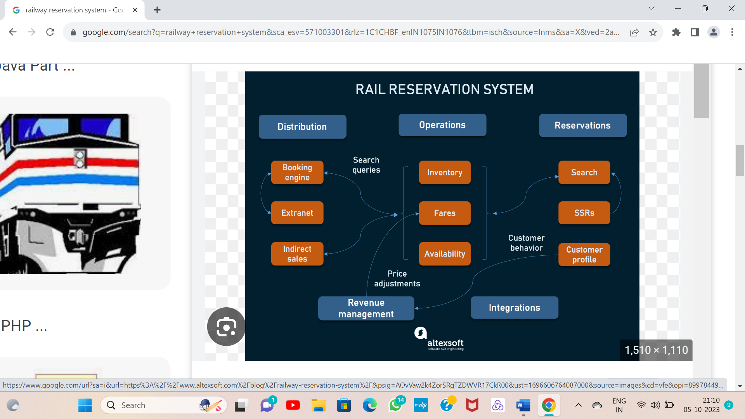

The current state of railway reservation technology

Unfortunately, railways are not integrated into the travel ecosystem as airlines, hotels, rental cars, or even cruises are. Visit some of the largest online travel agencies such as Expedia or Booking.com that dominate travel distribution on the web and you won’t find rail reservations in them. Of course, there are specialized OTAs like Trainline, but this only further isolates the passenger rail industry from the rest of the travel providers. Let’s analyze why this happens and what those differences are.

**Lack of railway cooperation**. Buying a ticket for a connecting flight is easy. Airlines have [interlining agreements](https://www.altexsoft.com/blog/connecting-flight/) with each other allowing passengers to seamlessly travel several flights, checking in once and getting rebooked in case of disruption. The lack of similar alliances among railways leads to less competition, lower passenger volumes, and minimal cross-border traveling.

**Lack of standardization.** Data sharing, which is the holy grail of travel distribution, is only possible when all systems operate in the similar way and use the same business logic, data format, and data exchange technologies. Airline technology, for example, was [spawned](https://www.altexsoft.com/blog/travel/history-of-flight-booking-crss-gds-distribution-travel-agencies-and-online-reservations/) from a single booking system — Sabre. Train technology didn’t follow the same evolution path, which created different approaches, processes, and products. As a result, even [global distribution systems (GDSs)](https://www.altexsoft.com/blog/travelport-vs-amadeus-vs-sabre-gds/) that power the largest network of travel providers have no more than 50 railway operators signed in.

**Lack of customer data**. Rail operators don’t know their customers. Because of the sporadic nature of train ticket shopping (people can purchase tickets online, in a kiosk at the station, or even on-board), you can’t create a holistic overview of your customers. This means that companies target a very generalized impression of a user and can’t accurately segment users and price their offers.

**Legacy technology**. Legacy systems are the bane of their existence for many traditional industries, railway included. They’re typically developed with outdated technology that has many limitations in today’s world; are expensive to manage and maintain, inclining developers to use workarounds and hacks to keep it alive; not developed from scratch, for example by customizing an airline reservation system; and bespoke, which creates inconsistency and stalls system-to-system connectivity.

Three of these problems (standardization, customer data, and technology) can be approached by implementing a modern, advanced rail reservation system. The fourth one (cooperation) will follow when you have the base for it. Let’s continue by examining what functions such a system will perform.

# Online Railway Ticket Reservation System

Online Railway ticket reservation is very useful nowadays. This is very important to design a good-working system software for ticket booking and related transactions. To design it, full-track documentation of models(ER, DFD, Class, Use-case, Activity, Sequence) is required as per as software development is concerned.

### **Features of the System:**

The Reservation system should contain the following features:

1. If a passenger wants to reserve ticket(s), firstly, he/she has to log in to the Railway system with valid credentials. Then, the passenger has to provide his/her details with the date of the journey, names of the passengers and their details, origin station details, destination station details, and the class type of the required ticket(s).
2. The Railway Reservation System will provide the available Train-list, and Seat-availability, via-details.
3. To book a ticket passengers can pay through online/offline mode. After successful payment of the ticket fare the System will generate the ticket and PNR no. will be given to the passenger. The System also keeps the payment details and sends them to the system Admin.
4. The Passenger can check PNR status (confirmed, RAC, waiting list) by entering the PNR no. into the Reservation system.
5. The Reservation system should store all train details, fare details (by zone, class, and date wise), PNR no, date of trains, etc. This maintenance should be controlled by the Admin.
6. The System also has refund rules which have a date of reservation, ticket fare, and refundable percentage. The passenger can simply cancel the ticket(s) by entering the PNR no and a cancel ticket request. After cancelation, the Admin will pass the refundable amount to the System and the System will give the refundable amount to the passenger.

### ****Features of the System:****

The Reservation system should contain the following features:

1. If a passenger wants to reserve ticket(s), firstly, he/she has to log in to the Railway system with valid credentials. Then, the passenger has to provide his/her details with the date of the journey, names of the passengers and their details, origin station details, destination station details, and the class type of the required ticket(s).
2. The Railway Reservation System will provide the available Train-list, and Seat-availability, via-details.
3. To book a ticket passengers can pay through online/offline mode. After successful payment of the ticket fare the System will generate the ticket and PNR no. will be given to the passenger. The System also keeps the payment details and sends them to the system Admin.
4. The Passenger can check PNR status (confirmed, RAC, waiting list) by entering the PNR no. into the Reservation system.
5. The Reservation system should store all train details, fare details (by zone, class, and date wise), PNR no, date of trains, etc. This maintenance should be controlled by the Admin.
6. The System also has refund rules which have a date of reservation, ticket fare, and refundable percentage. The passenger can simply cancel the ticket(s) by entering the PNR no and a cancel ticket request. After cancelation, the Admin will pass the refundable amount to the System and the System will give the refundable amount to the passenger.